Architectural Drawing and Design I Syllabus
2018-2019
Mr. Wilson
770-445-5100
E-mail: ajwilson@paulding.k12.ga.us

Course Description: Architectural Drawing and Design I is a one-credit course that introduces students to the basic terminology, concepts, and principles of architectural design. Emphasis is placed on house designs, floor plans, roof designs, elevations (interior and exterior), schedules, and foundations. The standards are aligned with the drafting and design standards in Georgia’s technical colleges, thus helping students qualify for advanced placement should they continue their education at the postsecondary level. Further, the standards are aligned with the national standards of the American Design Drafting Association (ADDA). Students who successfully complete this and other drafting courses should be prepared to take the Drafter Certification Examination from the ADDA. Competencies for the co-curricular student organization, SkillsUSA, are integral components of both the core employability skills standards and the technical skills standards. SkillsUSA activities should be incorporated throughout instructional strategies developed for the course.

Textbook: Architecture Residential Drafting and Design. Author: Clois Kicklighter (Replacement Costs: to be determined)

Materials needed: flash drive (64GB.), architectural, civil scale, xacto knife, xacto blades

Standards: Standards for this course can be found at the following web address:
http://www.georgiastandards.org/career.aspx?PageReq=HSPhaseI

Course Writing Assignments: Throughout the course year, each student will be required to write a minimum of 18 design article summaries. Students will be given instructions at the beginning of the course which will assist in the proper format for these documents.

Grade Composition: Students will be given assignments sheets in advance which will provide dates and deadlines for all objective tests, projects and written assignments.

Paulding County Scale  90 to 100 A  80 to 89 B  70 to 79 C  69 & below F | Categories:  Summative: 60%  Formal: 25%  Informal: 0%  EOCT/Final Exam: 15%

Summative grades Written Test, Oral Test, Drawing Test, Measuring Test

Formal grades: Classroom assignments, Design Articles, Homework

Informal grades: Return of sign progress reports,

Make Up Policy:

- Class assignments, test, and quizzes must be made up within 3 days after student returns to class.
- Design articles are due the day of return.

Architectural Drawing and Design I Syllabus

.2018-2019
Mr. Wilson
770-445-5100
E-mail: ajwilson@paulding.k12.ga.us

Group Assignments: In today’s workplace, teamwork is vital to most organizations and institutions. In this course, many of the assignments given will be completed in small groups. It is the students’ responsibility to make sure that ALL GROUP WORK is accurately completed and submitted as scheduled. It is expected that all group members are aware of all aspects of the project as well as have access to all pieces of the assignment whether or not a group member is present. Therefore, it is in the student’s best interest to share appropriate contact information with his group members. Remember, what happens in your group is often similar to what occurs in a real civic, administrative or political group. Problems such as coordination, division of work, leadership, disagreement, voting, dissent and even evaluation are a part of life. Final Note: If you fear problems are occurring in your group, it is your responsibility to inform me as soon as possible. Waiting until your project is due or even mostly completed to share any concerns regarding your group work is inappropriate and may result in unsatisfactory grades.

Computer Activities: It is a privilege to have access to the internet and other technology available in the computer labs. PLEASE use the computers with care. No Websites should be accessed that are not assigned by the instructor or that have not received approval from the instructor. No software, music, videos, headphones, or cell phones are allowed to be used in the classroom computer lab. Students are not allowed to download materials such as screen savers, games, etc. from the internet or CHANGE any settings. Violation of these and other rules as listed in the student handbook or technology use form will result in appropriate discipline procedures.

Consequences: Disruptions to teaching will not be tolerated and will be handled according to the Student Handbook. A progressive discipline plan will be followed that includes: 1). Warning; 2). Private Conference; 3) Possible removal from CBE Program

Teacher Availability: I will be available after school from 3:45 – 4:15 every Tuesday and before school from 7:45 – 8:15 every Thursday for students needing extra help. Because my morning and afternoon duty schedule is subject to change, please schedule an appointment at least 24 hours in advance.

Rules: No food or drink in class.

*I reserve the right to make changes to the syllabus as student achievement dictates.
“It is not your parents responsibility to make sure that you do your work ”

Student Printed Name________________________________ Parent Printed Name___________________________

Student Signature_______________________________________ Parent Signature___________________________

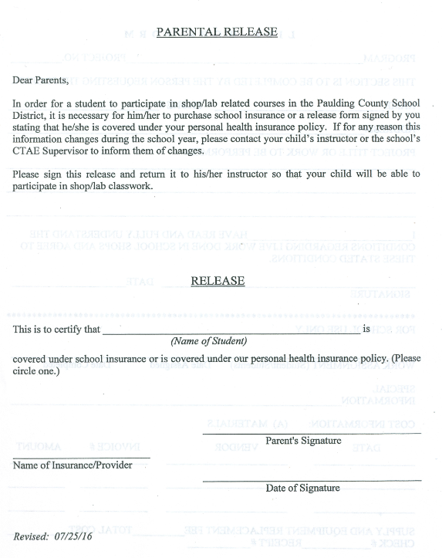
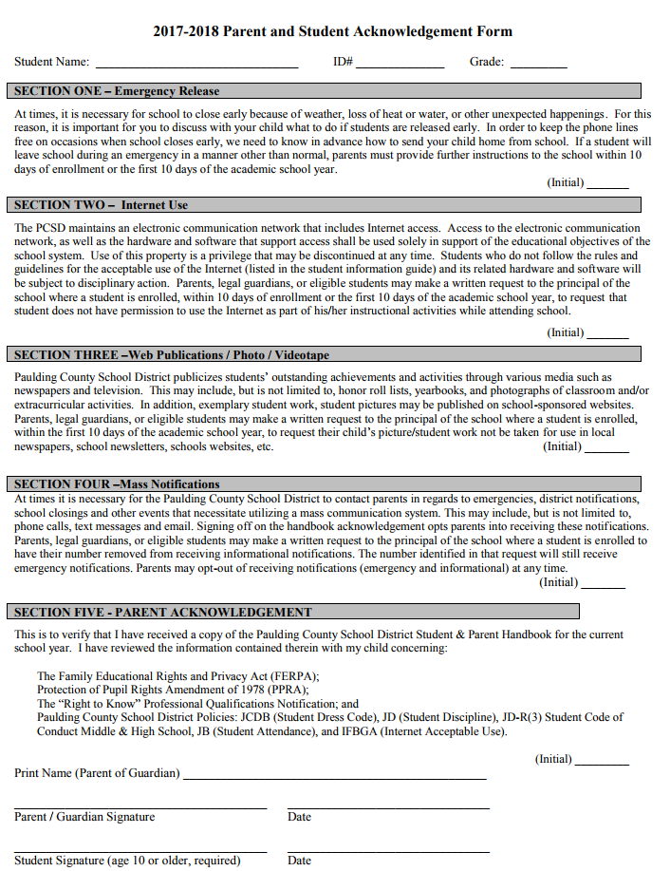
Architectural Drawing and Design I Standards
Course Number 48.54500

AC-ADDI-1

Standard: Demonstrate employability skills required by business and industry.
  - Communicate effectively through writing, speaking, listening, reading, and interpersonal abilities.
  - Demonstrate creativity by asking challenging questions and applying innovative procedures and methods.
  - Exhibit critical thinking and problem solving skills to locate, analyze and apply information in career planning and employment situations.
  - Model work readiness traits required for success in the workplace including integrity, honesty, accountability, punctuality, time management, and respect for diversity.
  - able to work independently and apply team work skills.

  - Present a professional image through appearance, behavior and language.
AC-ADDI-2
Identify components related to the architectural design process.
  - Describe the elements and principles of design.
  - Research historical architectural styles.
  - Explain the steps in the design process.
  - Analyze building sites.
  - Identify and summarize elements of sustainable design.
  - Interpret considerations of universal design.

AC-ADDI-3
Demonstrate architectural drafting skills.
  - Read and interpret existing architectural drawings.
  - Measure using an architect’s and an engineer’s scale.
  - Calculate volume and area related to architectural drafting.

AC-ADDI-4
Prepare residential floor plans.
  - Research and describe general codes related to floor plans.
  - Sketch to scale residential floor plans.
  - Draw dimensioned floor plans using appropriate symbols.
  - Apply appropriate dimensioning rules.
  - Incorporate aspects of sustainable and universal design.
  - Demonstrate the use of the Computer-Aided Design (CAD) software.4.6 related to residential floor plans problem solving.

AC-ADDI-5
Research roof systems, styles and terminology.
  - Recognize and compile various styles and constructions of roof systems, including hip, gable, mansard, gambrel, shed, and flat.
  - Identify and explain basic roofing terminology, including: rise, run, slope, pitch, overhang, eave line, and ridge line.
  - Research and compare environmental and sustainability issues in relation to roof design.
  - Assess aesthetics of roofs.
  - Demonstrate the use of Computer-Aided Design (CAD) software related to problem solving roof systems.
Architectural Drawing and Design I Standards
Course Number 48.54500

AC-ADDI-6
Prepare elevations for residential drawings.
  - Explain the purpose of elevations.
  - Sketch elevations.
  - Create elevation drawings with labels and dimensions to include: roof slope and overhang, type of roofing, door and window location, and porches.
  - Demonstrate the use of Computer-Aided Design (CAD) software related to preparing elevations for residential drawings.

AC-ADDI-7
Demonstrate preparing schedules.
  - Explain the purpose of schedules on a set of architectural drawings.
  - Generate the following schedules: window, door, and finish.
  - Demonstrate the use of Computer-Aided Design (CAD) software related to preparing schedules.
AC-ADDI-8
Demonstrate preparing foundation plans.
  - Explain the purpose of foundation plans.
  - Identify different foundation systems and terminology, including: slab, crawl space, and basement.
  - Draw dimensioned foundation plans.
  - Demonstrate the use of Computer-Aided Design (CAD) software related to preparing foundation plans.
AC-ADDI-9
Maintain a course portfolio.
  - Complete a set of residential house plans incorporating course standards (ongoing).
  - Report summary reflections on the design processes utilized throughout the course.
  - Include ancillary assignments created throughout the course necessary to demonstrate mastery of standards.
AC-ADDI-10
Examine how SkillsUSA is a co-curricular part of career and technical education industry.
  - Explain the purpose, mission, objectives, motto, colors, official dress and other distinguishing characteristics of SkillsUSA.
  - Explain how participation in SkillsUSA can promote lifelong responsibility for community service, professional growth and development.
  - Explore the impact and opportunities that SkillsUSA can develop to bring business and industry together with education in a positive working relationship through innovative leadership and career development programs.
  - Explore the local, state, and national opportunities available to students through participation in SkillsUSA, including but not limited to conferences, competitions, community service, philanthropy, and other SkillsUSA activities.

